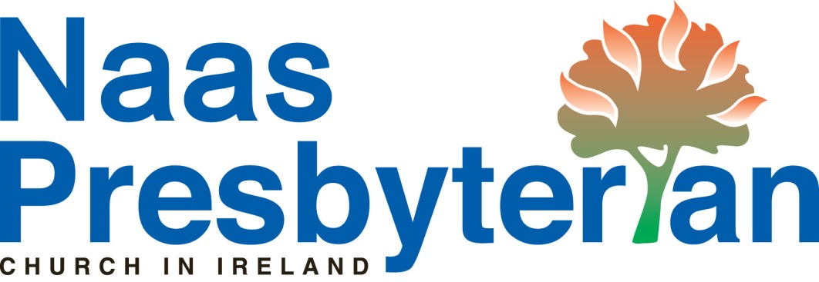
How to increase your giving…
with no additional cost to you!
As a church, we can reclaim the income tax which you have paid on the financial donations / offerings you contribute.
By completing a very simple form, the money you give can be increased by nearly 45%. As you will appreciate, this greatly benefits the finances of our congregation.
For example, if you contribute €500 during the year, that could be worth €724 after the income tax you have paid is reclaimed by the church. Similarly, €1,000 is worth €1,449. All without any extra cost to you!
Therefore, we are asking you to please consider completing the form (CHY3 Cert), which is also available from our Treasurer.
In order to take part in this scheme, you must be paying income tax, and your annual donation to Naas Presbyterian Church must exceed €250. The maximum annual donation, for which a claim can be made, is 10% of your annual income. These conditions are stipulated by the Revenue Commissioners.
Envelope scheme
In order to facilitate this, it is necessary for our Treasurer to record the donations which you make. To do so, we provide numbered envelopes to all those who complete the form (CHY3 Cert).
We assure you, that the only person who will know the amount you contribute will be our Treasurer. This information will be treated confidentially, and will only be used for the purpose of claiming the tax refunds.
Standing Order
This leaflet also provides an ideal opportunity to encourage you to consider making your offerings by standing order.
We can benefit from Tax reclaimed on these donations too.
To set this up, your bank will require the following details.
Account Name: Naas Presbyterian Church
Bank: Allied Irish Bank, 41 South Main St, Naas
Sort Code: 93–32–36
Account Number: 92838182
BIC: AIBKIE2D
IBAN: IE62AIBK93323692838182
Queries
If you have any questions or require more information about anything mentioned in this leaflet, please contact:
Mary Walsh (Treasurer) Mark Proctor (Minister)
045880892 / 0879044070 0858069156 marycwalsh39@gmail.com proctormz@yahoo.co.uk
Offerings And Appeals
Below is a list of the various offerings and appeals of our church, so that you can plan your giving:
Weekly Offering: This is the money you contribute in the offering bags each week (or by bank standing order), which helps to fund all we do as a congregation. In 2025, this totalled around €32.5k (including income tax we were able to reclaim).
United Appeal for Mission: This is the money placed in the box at the front or in the offering bags using a ‘United Appeal’ Envelope. This helps to fund the wider mission work of our denomination, both locally and globally. Our annual target for recent years has been around €2,000.
World Development Appeal: Each year our denomination supports a number of development projects in various parts of the world. We do this via the charity Tearfund. In 2025, €355 was donated by us as a congregation.
Christmas Gift Service: Each year, a local charity or cause is chosen and we bring gifts to support it. For the last several years we have donated non-perishable foodstuffs to the
Main Street FoodBank Project.
Moderator’s Appeal/s: These appeals are more occasional, but are normally launched in response to major disasters, to assist with funding relief work. For example, in 2022, together as a congregation we donated €605 to a Moderator’s Appeal for Ukraine, to assist those affected by the conflict there.

